**­High-level Data Link Control (HDLC)**

High-level Data Link Control (HDLC) is a group of communication protocols of the data link layer for transmitting data between network points or nodes. Since it is a data link protocol, data is organized into frames. A frame is transmitted via the network to the destination that verifies its successful arrival. It is a bit - oriented protocol that is applicable for both point - to - point and multipoint communications.

**BASIC CHARACTERISTICS:-**

**1.Primary station**

**2.secondary station**

**3.combined station**

**Transfer Modes**

HDLC supports two types of transfer modes, normal response mode and asynchronous balanced mode.

* **Normal Response Mode (NRM)** − Here, two types of stations are there, a primary station that send commands and secondary station that can respond to received commands. It is used for both point - to - point and multipoint communications.

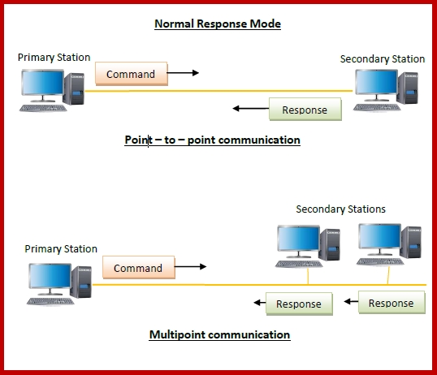

* **Asynchronous Balanced Mode (ABM)** − Here, the configuration is balanced, i.e. each station can both send commands and respond to commands. It is used for only point - to - point communications.

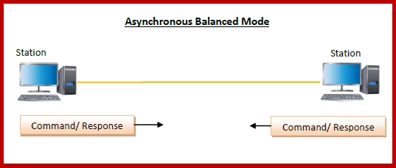

**HDLC Frame**

HDLC is a bit - oriented protocol where each frame contains up to six fields. The structure varies according to the type of frame. The fields of a HDLC frame are −

* **Flag** − It is an 8-bit sequence that marks the beginning and the end of the frame. The bit pattern of the flag is 01111110.
* **Address** − It contains the address of the receiver. If the frame is sent by the primary station, it contains the address(es) of the secondary station(s). If it is sent by the secondary station, it contains the address of the primary station. The address field may be from 1 byte to several bytes.
* **Control** − It is 1 or 2 bytes containing flow and error control information.
* **Payload** − This carries the data from the network layer. Its length may vary from one network to another.
* **FCS** − It is a 2 byte or 4 bytes frame check sequence for error detection. The standard code used is CRC (cyclic redundancy code)

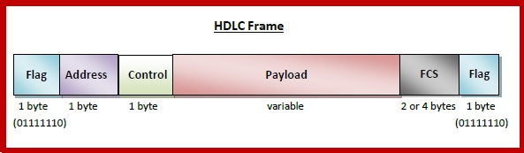

**Types of HDLC Frames**

There are three types of HDLC frames. The type of frame is determined by the control field of the frame −

* **I-frame** − I-frames or Information frames carry user data from the network layer. They also include flow and error control information that is piggybacked on user data. The first bit of control field of I-frame is 0.
* **S-frame** − S-frames or Supervisory frames do not contain information field. They are used for flow and error control when piggybacking is not required. The first two bits of control field of S-frame is 10.
* **U-frame** − U-frames or Un-numbered frames are used for myriad miscellaneous functions, like link management. It may contain an information field, if required. The first two bits of control field of U-frame is 11.

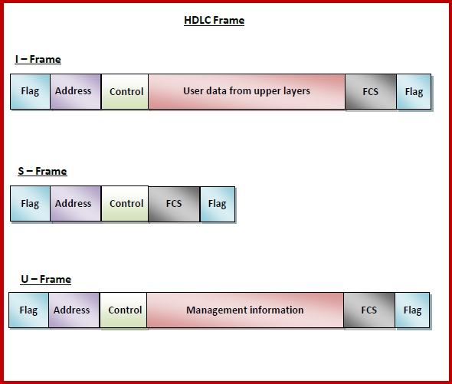

**OPERTAION OF HDLC:-**

1.INITIALIZATION

2.DATA TRANSFER

3.DISCONNECT

**Point-to-Point Protocol (PPP)**

Point - to - Point Protocol (PPP) is a communication protocol of the data link layer that is used to transmit multiprotocol data between two directly connected (point-to-point) computers. It is a byte - oriented protocol that is widely used in broadband communications having heavy loads and high speeds. Since it is a data link layer protocol, data is transmitted in frames.

**Services Provided by PPP**

The main services provided by Point - to - Point Protocol are −

* Defining the frame format of the data to be transmitted.
* Defining the procedure of establishing link between two points and exchange of data.
* Stating the method of encapsulation of network layer data in the frame.
* Stating authentication rules of the communicating devices.
* Providing address for network communication.
* Providing connections over multiple links.
* Supporting a variety of network layer protocols by providing a range os services.

**Components of PPP**

Point - to - Point Protocol is a layered protocol having three components −

* **Encapsulation Component** − It encapsulates the datagram so that it can be transmitted over the specified physical layer.
* **Link Control Protocol (LCP)** − It is responsible for establishing, configuring, testing, maintaining and terminating links for transmission. It also imparts negotiation for set up of options and use of features by the two endpoints of the links.
* **Authentication Protocols (AP)** − These protocols authenticate endpoints for use of services. The two authentication protocols of PPP are −
  + Password Authentication Protocol (PAP)
  + Challenge Handshake Authentication Protocol (CHAP)
* **Network Control Protocols (NCPs)** − These protocols are used for negotiating the parameters and facilities for the network layer. For every higher-layer protocol supported by PPP, one NCP is there. Some of the NCPs of PPP are −
  + Internet Protocol Control Protocol (IPCP)
  + OSI Network Layer Control Protocol (OSINLCP)
  + Internetwork Packet Exchange Control Protocol (IPXCP)
  + DECnet Phase IV Control Protocol (DNCP)
  + NetBIOS Frames Control Protocol (NBFCP)
  + IPv6 Control Protocol (IPV6CP)

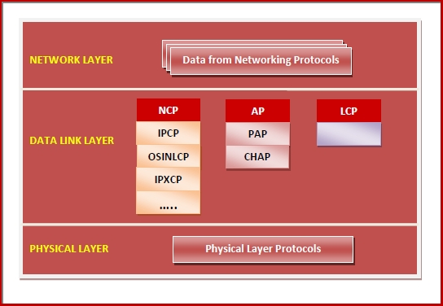

**PPP Frame**

PPP is a byte - oriented protocol where each field of the frame is composed of one or more bytes. The fields of a PPP frame are −

* **Flag** − 1 byte that marks the beginning and the end of the frame. The bit pattern of the flag is 01111110.
* **Address** − 1 byte which is set to 11111111 in case of broadcast.
* **Control** − 1 byte set to a constant value of 11000000.
* **Protocol** − 1 or 2 bytes that define the type of data contained in the payload field.
* **Payload** − This carries the data from the network layer. The maximum length of the payload field is 1500 bytes. However, this may be negotiated between the endpoints of communication.
* **FCS** − It is a 2 byte or 4 bytes frame check sequence for error detection. The standard code used is CRC (cyclic redundancy code)

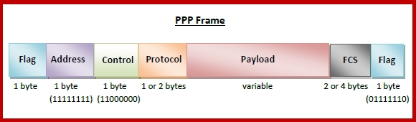

**Byte Stuffing in PPP Frame** − Byte stuffing is used is PPP payload field whenever the flag sequence appears in the message, so that the receiver does not consider it as the end of the frame. The escape byte, 01111101, is stuffed before every byte that contains the same byte as the flag byte or the escape byte. The receiver on receiving the message removes the escape byte before passing it onto the network layer.